 Experiment: - 2

## Student Name: Sahul Kumar Parida UID: 20BCS4919

**Branch: CSE Section/Group: WMA-904/B**

**Semester: 5th Subject Code: 20CSP-317**

**Subject Name: MACHINE LEARNING LAB**

**Aim/Overview of the practical:**

Implement Data Visualization.

# Task to be done:

To perform Data Visualization on any standard dataset.

# Apparatus/Simulator used:

* Jupyter Notebook/Google Collab
* Python
* pandas Library
* seaborn Library
* Standard Dataset

# Code and Output:

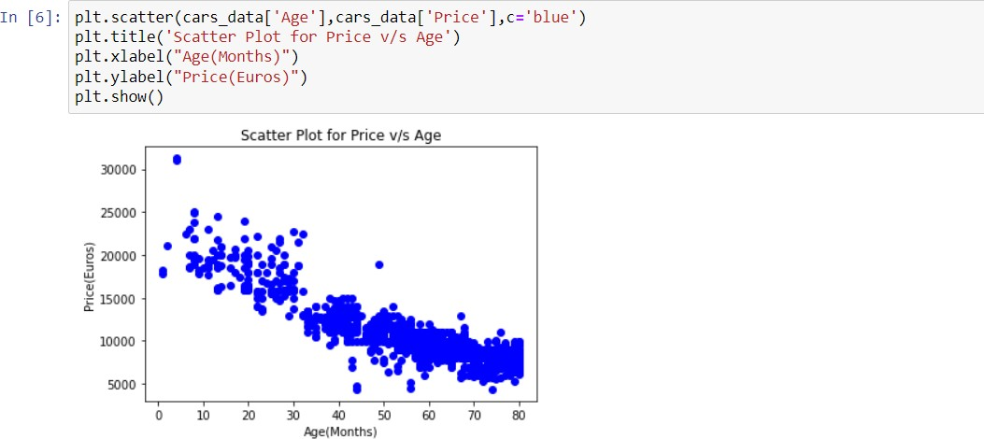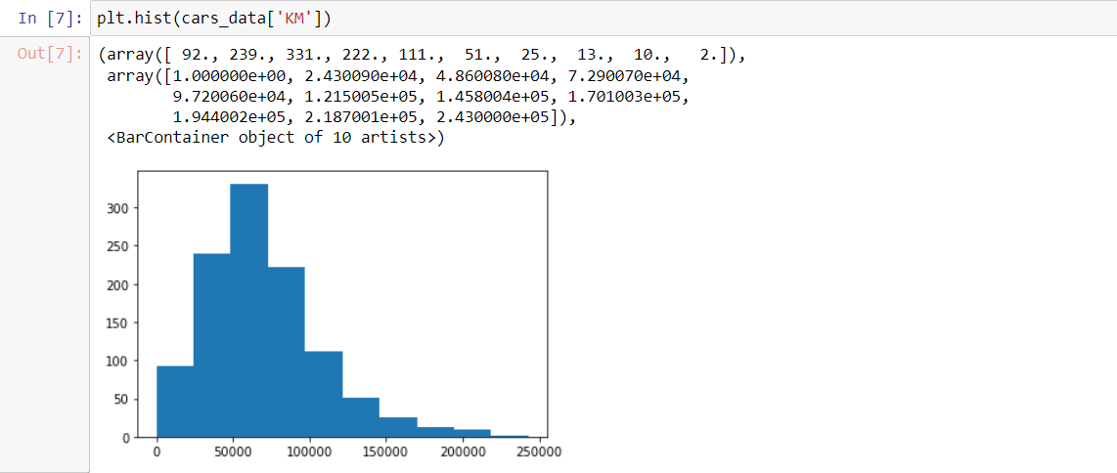Plotted Histogram

In [9]: plt.hist(cars data[’KM’],color:'yellow',edgecolor='green’,bins=6) plt.title('Histogram of KM')

plt.x1abel(’Kilometer') plt.y1abel(’Frequency')

Out [9 ] : Text (6, 6. 5, ' Frequency ' )

Histogram of Kfd

IOQ

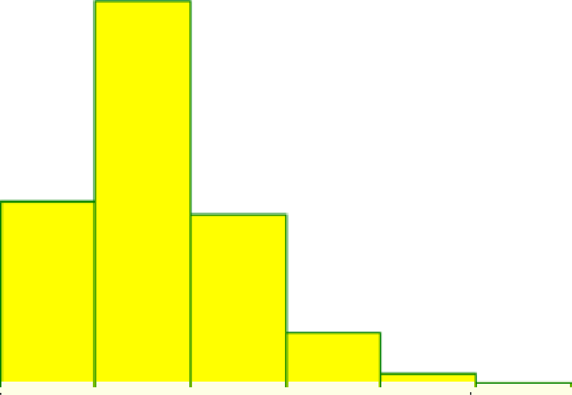

50000 100000 150000 200000 2S0000

0

Kilometer

In [15]: plt.bar(index,counts,co1or=['orange’,'green’,'pink']) plt.title('BarPlot for fuel types')

plt.xlabel(’Fuel Types') pit.ylabel(’Frequency') pit.xticks(index,FuelType,rotation=90) pit.show()

BarPlot for fuel types

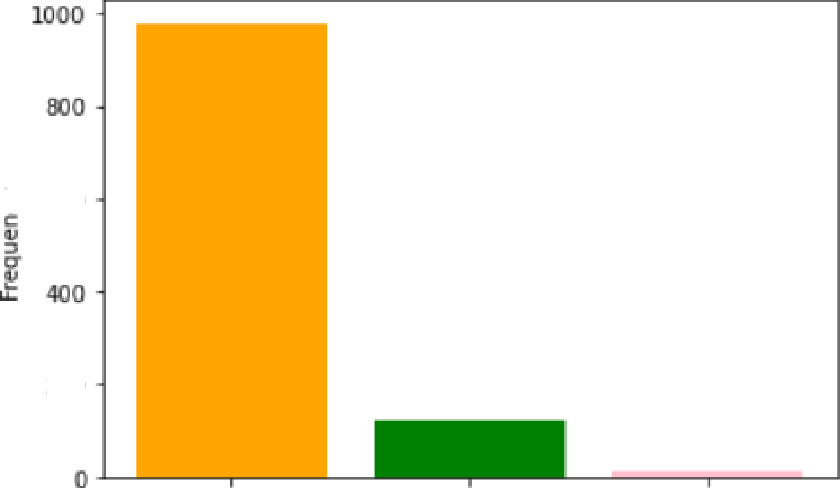

? d00

Fuel Types

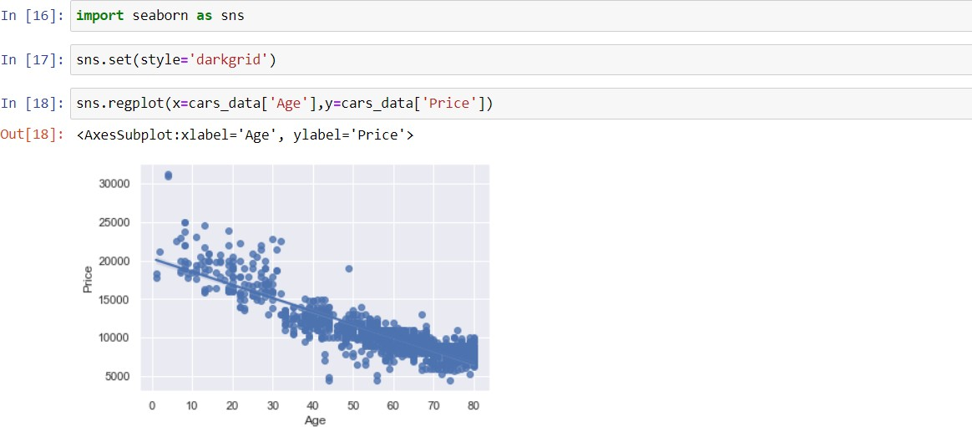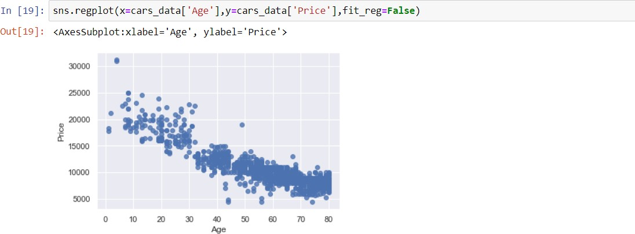To remove the regression line we have to make it false as its default value is true.

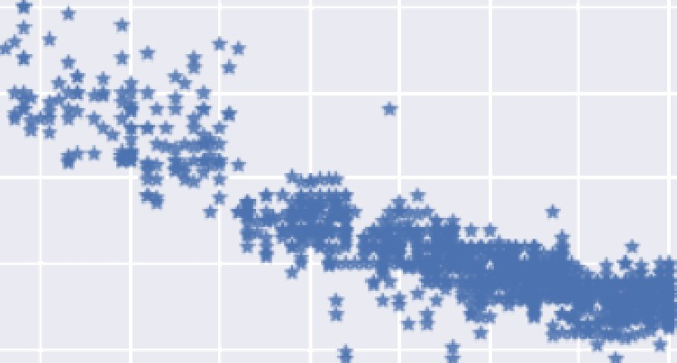In [Z0]: sns.regplot(x:cars data['Age'],y:cars data[’Price'],fit reg:FaIse,marker:”*”) Out[Z0]: <AxesSubplot:xlabel='Age’, ylabel=’Price’›

15000

10D0O



In [22]: sns.lmplot(x='Age',y='"rice',aata=cars data,fit reg:Fa1se,hue='Fue1Type',legend=True,palette=”Set1”)

Out 22]: ‹seaborn.axisgrid.FacetGrid at 0x2le37793b20›





15000

10000

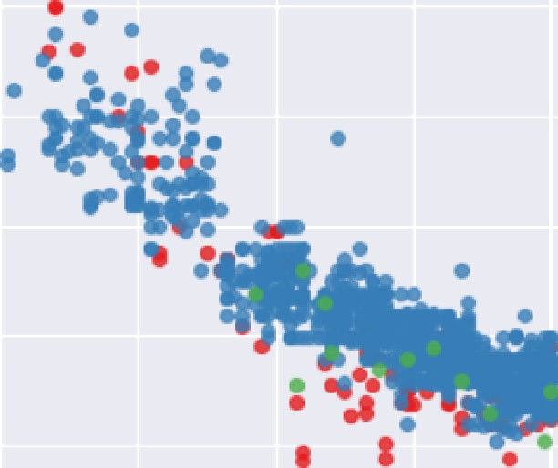Age

Fue@ype

* OewI



In [24]: sns.displot(cars_datd[’Age'])

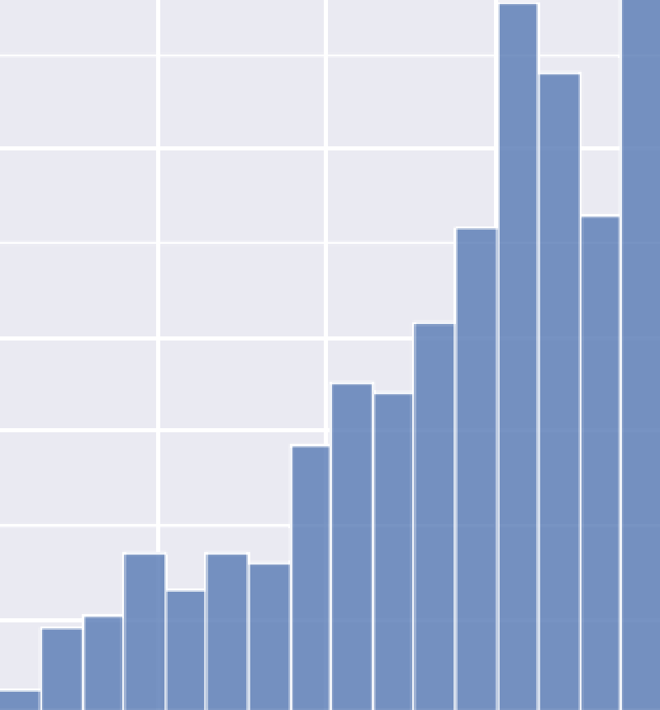Out 24]: <seaborn.axisgrid.FacetGrid at 0x2le3a448lf0›

120

Count

In [Z5]: sns.displot(cars_data[’Age'],color=’pink’,bins=8)

Ou I [ 25 ] : <seaborn . ax1sgr 1d. FacelGr1d at 0x21e377Be670>



In [26]: sns.countplot(x='Fuel ype',data=cars data,hue=“Automatic“) Ou{[26]: <Axes5ubplot:xlabel='FuelType', ylabel='count'>





0

count

DeseI Petroi

FuelType

CNG

In [27]: sns.boxplot(y=cars data['Price'])

Out [27] : ‹Axe ssubplot : ylabel= ' Pr1ce ' ›

30000

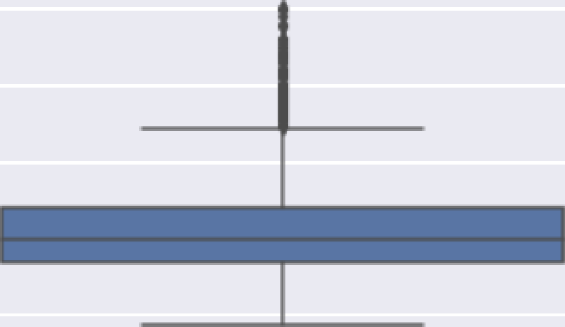AOOO

20000

15000

10000

BOO

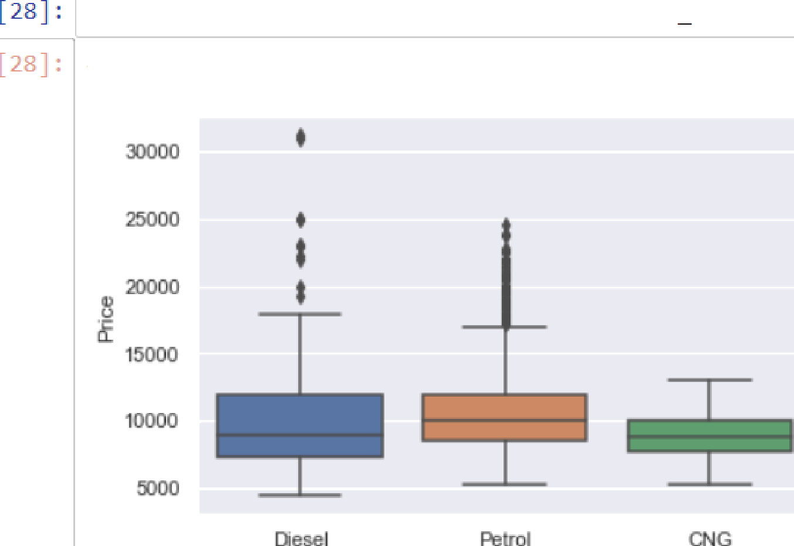I n sns.boxplot(x=cars data['FuelTy pe'],y=cars data[' Price '])

<AxesSubplot:xlabel='FuelType', ylabel='Price'>





